Tecgraf Report about the study of EDRC Use Case 2

(February 2016, version prepared by Geiza M. Hamazaki da Silva and Livia Ruback, Tecgraf Institute/PUC-Rio)

Summary

1. Introduction 3
2. RFQ information for one pressure 4
2.1 Template ClassOfParticipationDefinition 4
2.1.1 Problems identified 5
2.2 Template ClassOfAssemblyDefinition 5
2.2.1 Problems identified 6
2.3 Template SpecializationByCompoundType 7
2.3.1 Problems identified 8
2.4 Template SpecializationOfClassOfIndividual 8
2.4.1 Problems identified 9
2.5 Template ClassOfContainmentDefinition 9
2.5.1 Problems identified 10
2.6 Template ClassOfFeatureWholePartDefinition 11
2.6.1 Problems identified 12
2.7 Template ClassificationOfIndividual 12
2.7.1 Problems identified 13
2.8 Template ClassifiedDefinitionOfClassOfIndividualWithInformationRepresentation 13
2.8.1 Problems identified 14
3. Reply to the RFQ information 14
3.1 Template ProductClassFulfilsClassOfFunctionPlace 14
3.1.1 Problems identified 15
3.2 Template ClassOfIndividualHasMonetaryValue 15
3.2.1 Problems identified 16
3.3 Template ClassifiedDefinitionOfClassOfIndividualWithInformationRepresentation 16
3.3.1 Problems identified 17
4. Proposal 18
5. Data Specification 21
5.1 Object Declarations 21
5.2 Template Pattern 25

Introduction

This document describes the interpretation of the EDRC Use Case 2, about the files pressure_transmitter_rfq_1.ttl and pressure_transmitter_rfq_1_reply.ttl, which contains respectively RFQ information for one pressure transmitter and a reply to it.
For a matter of understanding, Section 2 presents the RFQ information for one pressure transmitter explaining separately the main templates and its instances. Section 3 follow the same approach, but for the reply to the RFQ information. Section 4 describes a proposal for solving the inconsistencies found in the pressure_transmitter_rfq_1.ttl and Section 5 shows a First Order Logic representation of the Object Declarations and the Templates Patterns used to construct the EDRC User Case 2.

Notes:
- All resources identifiers presented in this document are shortened, for instance, the resource id83f1614d-649b-4876-ae1e-34721972e9bc is being represented as “id83f…”.
- All the cardinality number missed in the templates is being represented as “[X]”
- Different colors are used to show the resources: yellow boxes represents the templates and its instances, blue boxes brings the roles object of the templates and gray boxes show other templates that relates with the current template.

RFQ information for one pressure
The Request For Quotation information for one pressure transmitter file (pressure_transmitter_rfq_1.ttl) comprises the resources presented as follow. The templates and its instances in bold are presented in next sections.
Resource | rdf:type | Section
id69516a23-2029-4f05-a714-3d269cc78de5 | dm:ClassOfActivity
id7176e82f-fe79-43eb-b7c3-6f8132751085 | dm:ClassOfArrangedIndividual
id73806964-ca9a-4b2a-a997-13d6a57d4c6d | dm:ClassOfArrangedIndividual
id83f1614d-649b-4876-ae1e-34721972e9bc | dm:ClassOfArrangedIndividual
id0109f0bf-ac9d-411f-85cd-785ee3194d9e | dm:ClassOfInanimatePhysicalObject
id05c6754c-b2b7-4a7f-89c1-5e31940b5516 | dm:ClassOfInanimatePhysicalObject
id05796c76-5f03-4e11-9a02-a1db079abec7 | dm:ClassOfInanimatePhysicalObject
id96b6298e-8fe2-4939-9609-5cd47e0f0516 | dm:ClassOfInanimatePhysicalObject,  pcardl:R-c898dddf-932e-4216-bf99-0f40df3847f4
id20a39ca3-eb99-44be-aacf-8dae3b3f99cb | dm:ClassOfInformationRepresentation,  pcardl:R-4d2153f8-2b65-4bee-9efb-a2fcac12f284 ("REQUEST FOR QUOTATION")
id3dd5e9f4-f0ed-4e88-90e8-47cee5debf9c | dm:ClassOfInformationRepresentation,  pcardl:R-a3107083-c97f-458d-aa24-d3785a0a1835 ("RFQ ITEM")
id91a437fa-20de-470b-83d0-2cdfe4a61914 | dm:FunctionalPhysicalObject
idfdc37bd5-690c-4596-b603-677ba6f7d88a | tpl:ClassificationOfIndividual | 2.7
idf2ad1e4e-7061-4a6a-867a-91f8e023a65b | tpl:ClassifiedDefinitionOfClassOfIndividualWithInformationRepresentation | 2.8
id1395ad4b-81d5-4f46-a90b-7593f98edd32 | tpl:ClassifiedIdentificationOfIndividual
id00394ae2-f71f-4d9b-b23e-0921320a2292 | tpl:ClassOfAssemblyDefinition | 2.2
id3ff4a9d3-be07-4679-84aa-e25c1daac45c | tpl:ClassOfAssemblyDefinition | 2.2
idc10d6602-0aa9-4a71-8579-9e8c18dac8de | tpl:ClassOfContainmentDefinition | 2.5
id1d2bf4dc-6b26-44a7-a5ba-96a4784ecd44 | tpl:ClassOfFeatureWholePartDefinition | 2.6
idef595e28-52b2-42fd-b714-1368087d85e7 | tpl:ClassOfFeatureWholePartDefinition | 2.6
id7cbfe727-ba44-49fe-83d2-50c5edb17e5d | tpl:ClassOfIndividualHasIndirectPropertyWithBoundingValues
id5a5afdec-c690-4a37-a869-6b33d15dd92a | tpl:ClassOfIndividualHasIndirectPropertyWithValue
idf84912f2-0994-4ac5-b0b1-dd64376dd345 | tpl:ClassOfIndividualHasIndirectPropertyWithValue
id0c73c960-9164-46f3-959a-70a6fd5a31b2 | tpl:ClassOfParticipationDefinition | 2.1
id75fe4685-a1f7-4e88-b4c5-9b0a9fa707fa | tpl:ClassOfParticipationDefinition | 2.1
idc1b54729-7deb-4764-a16a-0a9d29b1582e | tpl:CompositionOfClassOfInformationRepresentation
id1f575f73-ea84-43ab-8980-b647f73965d4 | tpl:SpecializationByCompoundType | 2.3
id24bb682e-d3c8-4245-999c-d31cf54f664a | tpl:SpecializationByCompoundType | 2.3
id0e7d3ad9-ab84-43f9-9f1a-9b980dfe7973 | tpl:SpecializationOfClassOfIndividual | 2.4
id42d99e6e-a100-4574-865b-dcb1761ef742 | tpl:SpecializationOfClassOfIndividual | 2.4
id84217d48-1196-439b-8dfe-cfcd7376b08c | tpl:SpecializationOfClassOfIndividual | 2.4
idc5c4e0d5-f495-4fc8-96f3-5e8fb8944fb6 | tpl:SpecializationOfClassOfIndividual | 2.4
idf9f811d7-6344-49f1-82aa-1da40a7c2db0 | tpl:SpecializationOfClassOfIndividual | 2.4

Template ClassOfParticipationDefinition

The template specification is shown in http://15926.org/templatespecs/CL-ACTIV-01.xml.
The template roles are the following (see link above):
Role No | Role Name | Role Object Type
1 | hasActivityType | dm:ClassOfActivity
2 | hasParticipantType | dm:ClassOfIndividual
3 | hasParticipantRole | dm:Role
4 | hasDefined | dm:ClassOfParticipation
5 | hasCardinalityOfActivity | dm:Cardinality
6 | hasCardinalityOfParticipant | dm:Cardinality

Figure 1 shows the two ClassOfParticipationDefinition template instances of the pressure_transmitter_rfq_1.ttl file.
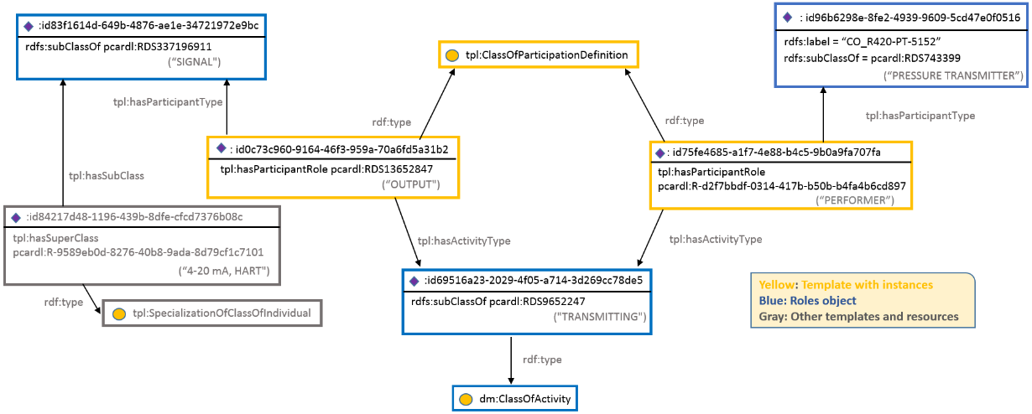
Figure 1 ClassOfParticipationDefinition template instantiation
The represented information described in the template specification (see link above) says that:
“[hasParticipantType] shall participate in [hasCardinalityOfActivity] member of [hasActivityType] in the role of [hasParticipantRole]”.
- For the first template instance (id0c7…), one can say:
“[id83f…] (subclass of SIGNAL) shall participate in [X] member of [id695…] (subclass of TRANSMITTING) in the role of [OUTPUT]”,

which means that

a signal artifact gives an output signal.

- For the second template instance (id75f…), one can say:

“[id96b…] (subclass of PRESSURE TRANSMITTER) shall participate in [X] member of [id695…] (subclass of TRANSMITTING) in the role of [PERFORMER] ”.

which means that

The pressure transmitter perform in the transmitting.

2.1.1 Problems identified

(a) As pointed out in the specification, “at instantiation of this template it is mandatory to add meta:valEffectiveDate with the dateTime that the represented information became effective”. This instance does not contain this date required.
(b) Some template roles are missing: (4) hasDefined, (5) hasCardinalityOfActivity and (6) hasCardinalityOfParticipant.

Template ClassOfAssemblyDefinition

The template specification is shown in http://15926.org/templatespecs/CL-STRUC-03.xml
The template roles are the following (see link above):
Role No | Role Name | Role Object Type
1 | hasClassOfWhole | dm:ClassOfArrangedIndividual
2 | hasClassOfPart | dm:ClassOfIndividual
3 | hasCardinalityOfWhole | dm:Cardinality
4 | hasCardinalityOfPart | dm:Cardinality

Figure 2 shows the two ClassOfAssemblyDefinition template instances of the pressure_transmitter_rfq_1.ttl file.
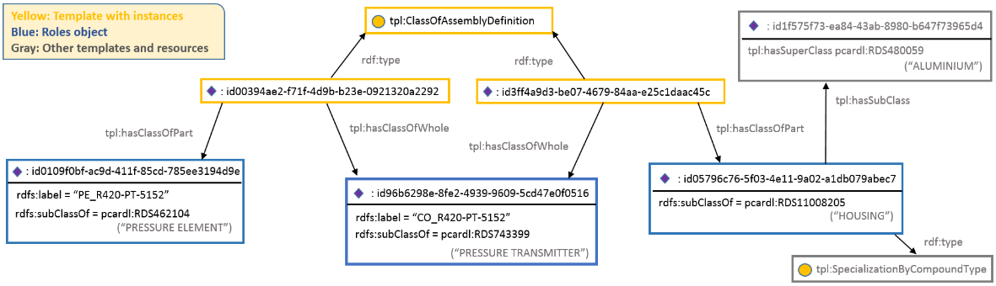
Figure 2 ClassOfAssemblyDefinition template instantiation
The represented information described in the specification (see link above) says that:
“Any member of ClassOfArrangedIndividual [hasClassOfWhole] is composed of [hasCardinalityOfWhole] member(s) of ClassOfIndividual [hasClassOfPart] in an assembly”.
- For the first template instance (id003…), one can say:
“Any member of ClassOfArrangedIndividual [CO_R420-PT-5152] (subclass of PRESSURE TRANSMITTER) is composed of [X] member(s) of ClassOfIndividual [PE_R420-PT-5252] (subclass of PRESSURE ELEMENT) in an assembly”,
which means that
“The PRESSURE TRANSMITTER [CO_R420-PT-5152] has a the PRESSURE ELEMENT [PE_R420-PT-5152] as a part”
- For the second template instance (id3ff…), one can say:

“Any member of ClassOfArrangedIndividual [CO_R420-PT-5152] (subclass of PRESSURE TRANSMITTER) is composed of [X] member(s) of ClassOfIndividual [id057…] in an assembly”,

which means that
“The PRESSURE TRANSMITTER [CO_R420-PT-5152] has a HOUSING as a part”.

Problems identified

- As pointed out in the specification, “at instantiation of this template it is mandatory to add meta:valEffectiveDate with the dateTime that the represented information became effective”. This instance does not contain this date required.
- Some template roles are missing: (3) hasCardinalityOfRole and (4) hasCardinalityOfPart

2.3 Template SpecializationByCompoundType

The template specification is shown in http://15926.org/templatespecs/CL-MATL-01.xml
The template roles are the following (see link above):
Role No | Role Name | Role Object Type
1 | hasSubClass | dm:ClassOfArrangedIndividual
2 | hasSuperClass | dm:ClassOfCompound

Figure 3 shows the two SpecializationByCompoundType template instances of the pressure_transmitter_rfq_1.ttl file.

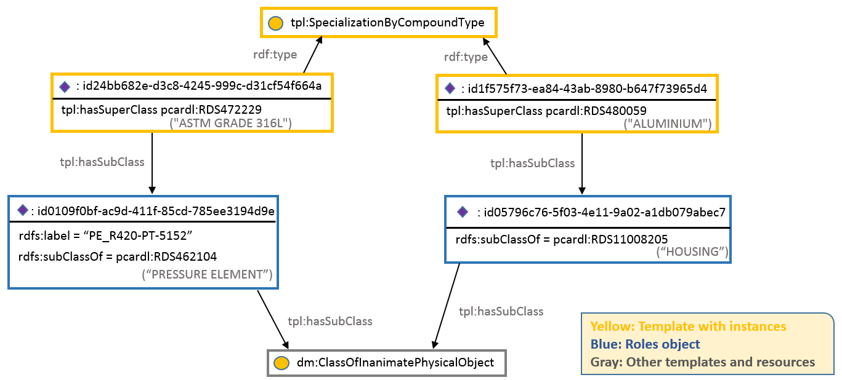
Figure 3 SpecializationByCompound template instantiation
The represented information described in the specification (see link above) says that:
“Any member of ClassOfArrangedIndividual [hasSubClass] is of the [hasSuperClass] compound type.”
- For the first template instance (id24b…), one can say:
“Any member of ClassOfArrangedIndividual [PE_R420-PT-5152] (subclass of PRESSURE ELEMENT) is of the [ASTM GRADE 316L] compound type”,
which means that
“The PRESSURE ELEMENT PE_R420-PT-5152 is made of a stainless steel material (ASTM GRADE 316L)”
- For the second template instance (Id1f5…), one can say:

“Any member of ClassOfArrangedIndividual [id057…] (subclass of HOUSING) is of the [ALUMINIUM] compound type”,
which means that
“The HOUSING is made of ALUMINIUM”.

Problems identified

- As pointed out in the specification, “at instantiation of this template it is mandatory to add meta:valEffectiveDate with the dateTime that the represented information became effective”. This instance does not contain this date required.

Template SpecializationOfClassOfIndividual

The template specification is shown in http://15926.org/templatespecs/CL-SPECN-01.xml
The template roles are the following (see link above):

Role No | Role Name | Role Object Type
1 | hasSubClass | dm:ClassOfIndividual
2 | hasSuperClass | dm:Class

Figure 4 shows the four SpecializationOfClassOfIndividual template instances of the pressure_transmitter_rfq_1.ttl file.
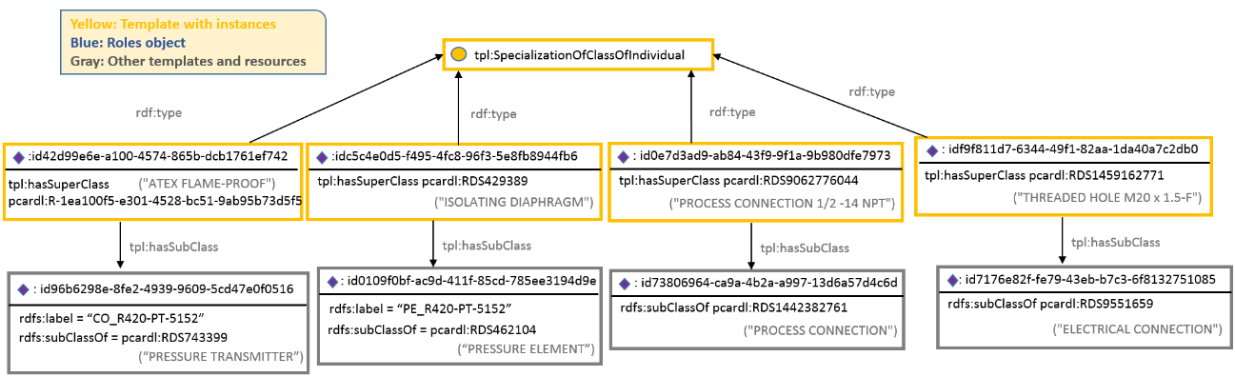
Figure 4 SpecializationOfClassOfIndividual template instantiation
The represented information described in the specification (see link above) says that:
“Any member of [hasSubClass] is also a member of [hasSuperClass].”
- For the first instance of the template (id42d…), one can say:

“Any member of [CO_R420-PT-5152] (subclass of PRESSURE TRANSMITTER) is also a member of the [ATEX FLAME-PROOF]”,

which means that

“The PRESSURE TRANSMITTER CO_420-PT-5152 is compliant to the ATEX FLAME-PROOF certification”.

- For the second instance of the template (idc5c…), one can say:

“Any member of [PE_R420-PT-5152] (subclass of PRESSURE ELEMENT) is also a member of the [ISOLATING DIAPHRAGM]”,

which means that

“The PRESSURE ELEMENT has an isolating diaphragm”.

- For the third instance of the template (id0e7…), one can say:

“Any member of [id738…] (subclass of PROCESS CONNECTION) is also a member of the [PROCESS CONNECTION ½ - 14 NPT]”,

which means that

“The process connection is of the ½ - 14 NPT type (1/2 inch diameter/ 14 threads per inch)”

- For the fourth instance of the template (idf9f…), one can say:

“Any member of [id717…] (subclass of ELECTRICAL CONNECTION) is also a member of the [THREADED HOLE M20 X 1.5 F]”,

which means that

The electrical connection is of the THREADED HOLE M20 x 1.5 F type (basic major diameter 20mm, 1.5 mm per thread, female)

2.4.1 Problems identified

(a) As pointed out in the specification, “at instantiation of this template it is mandatory to add meta:valEffectiveDate with the dateTime that the represented information became effective”. This instance does not contain this date required.

Template ClassOfContainmentDefinition

The template specification is shown in http://15926.org/templatespecs/CL-LOCTN-01.xml
The template roles are the following (see link above):
Role No | Role Name | Role Object Type
1 | hasClassOfContainer | dm:ClassOfIndividual
2 | hasClassOfContained | dm:ClassOfIndividual
3 | hasCardinalityOfContainer | dm:Cardinality
4 | hasCardinalityOfContained | dm:Cardinality

Figure 5 shows the ClassOfContainmentDefinition template instance of the pressure_transmitter_rfq_1.ttl file.
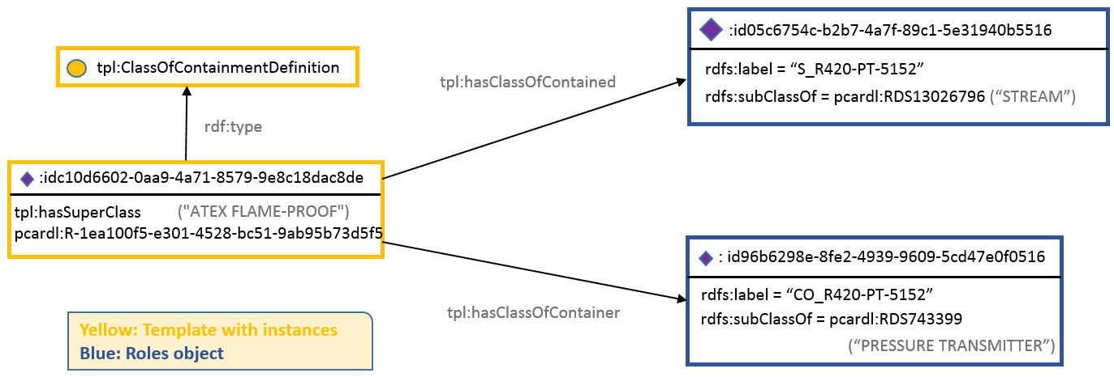
Figure 5 ClassOfContainmentDefinition template instantiation
The represented information described in the specification (see link above) says that:
“Any member of [hasClassOfContained] [may | shall] be contained in any member of [hasClassOfContainer].”
For the instance of the template (idc10…), one can say:
“Any member of [S_R420-PT-5152] (subclass of STREAM) may be contained in any member of [CO_R420-PT-5152] (subclass of PRESSURE TRANSMITTER)”,

which means that

“The PRESSURE TRANSMITTER CO_R420-PT-5152 for STREAMS is compliant to the ATEX FLAME-PROOF certification”.

2.5.1 Problems identified

- As pointed out in the specification, “at instantiation of this template it is mandatory to add meta:valEffectiveDate with the dateTime that the represented information became effective”. This instance does not contain this date required.
- Some template roles are missing: (3) hasCardinalityOfContainer and (4) hasCardinalityOfContained

Template ClassOfFeatureWholePartDefinition

The template specification is shown in http://15926.org/templatespecs/CL-STRUC-04.xml?cachebuster=0.32036900%201440772479
The template roles are the following (see link above):
Role No | Role Name | Role Object Type
1 | hasClassOfWhole | dm:ClassOfArrangedIndividual
2 | hasClassOfPart | dm:ClassOfFeature
3 | hasCardinalityOfWhole | dm:Cardinality
4 | hasCardinalityOfPart | dm:Cardinality

Figure 6 shows the ClassOfFeatureWholePartDefinition template instance of the pressure_transmitter_rfq_1.ttl file.

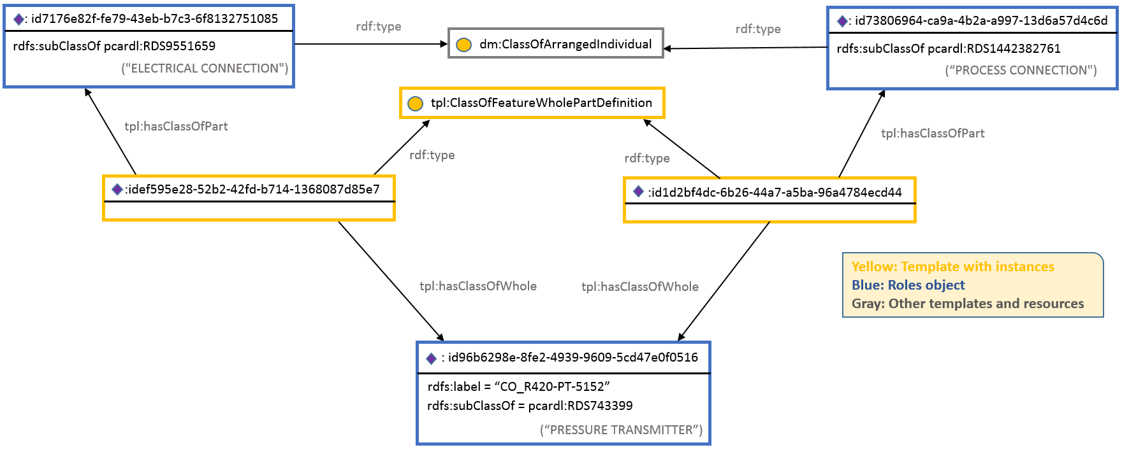
Figure 6 ClassOfFeatureWholePartDefinition template instantiation
The represented information described in the specification (see link above) says that:
“Any member of ClassOfArrangedIndividual [hasClassOfWhole] has [hasCardinalityOfWhole] member(s) of ClassOfIndividual [hasClassOfPart] as a Feature.”
- For the first instance of the template (idef5…), one can say:

“Any member of ClassOfArrangedIndividual [CO_R420-PT-5152] (subclass of PRESSURE TRANSMITTER) has [X] member(s) of ClassOfIndividual [id717…] (subclass of PROCESS CONNECTION) as a Feature”,

which means that

“The pressure transmitter has an electrical connection”.

- For the second instance of the template (id1d2…), one can say:

“Any member of ClassOfArrangedIndividual [CO_R420-PT-5152] (subclass of PRESSURE TRANSMITTER) has [X] member(s) of ClassOfIndividual [id1d2…] (subclass of ELECTRICAL CONNECTION) as a Feature”,

which means that

“The pressure transmitter has a process connection”.

Problems identified

- As pointed out in the specification, “at instantiation of this template it is mandatory to add meta:valEffectiveDate with the dateTime that the represented information became effective”. This instance does not contain this date required.
- Some template roles are missing: (3) hasCardinalityOfWhole and (4) hasCardinalityOfPart

Template ClassificationOfIndividual

The template specification is shown in http://15926.org/templatespecs/IN-CLSIF-01.xml
Note: This template is not present on the EDRC Use Case 2 Technical Documentation.
The template roles are the following (see link above):
Role No | Role Name | Role Object Type
1 | hasClassifier | dm:PossibleIndividual
2 | hasClassified | dm:ClassOfIndividual

Figure 7 shows the ClassificationOfIndividual template instance of the pressure_transmitter_rfq_1.ttl file.
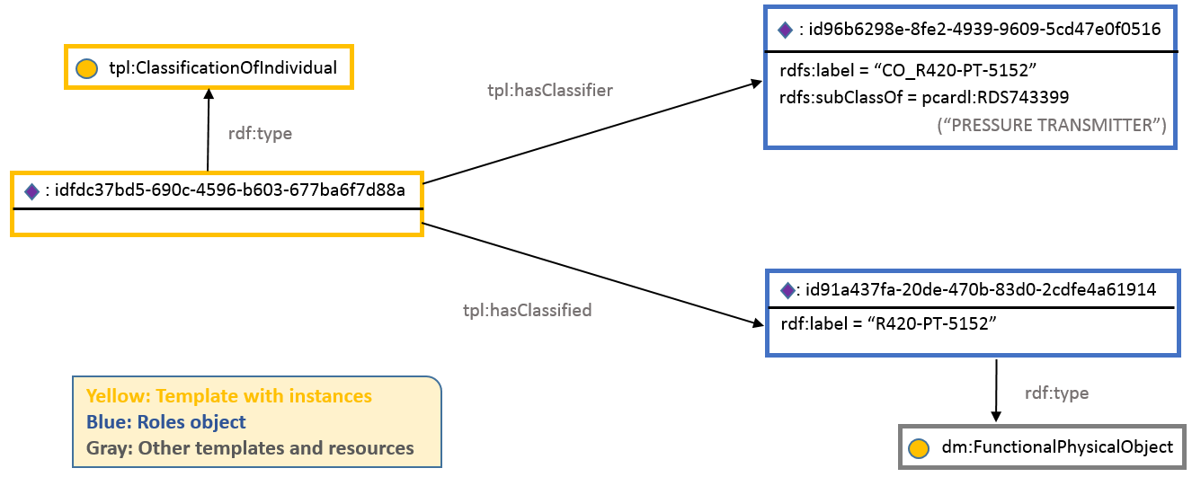
Figure 7 ClassificationOfIndividual template instantiation
The represented information described in the specification (see link above) says that:
“PossibleIndividual [hasClassified] is classified with [hasClassifier].”
For the instance of the template (idfdc…), one can say:
“Possible Individual [420-PT-5152] is classified with [CO_R420-PT-5152] (subclass of PRESSURE TRANSMITTER)”,

which means that
“The PRESSURE TRANSMITTER CO_R420-PT-5152 is the R420-PT-5152”.

Problems identified

- As pointed out in the specification, “at instantiation of this template it is mandatory to add meta:valEffectiveDate with the dateTime that the represented information became effective”. This instance does not contain this date required.

Template ClassifiedDefinitionOfClassOfIndividualWithInformationRepresentation

The template specification is shown in http://www.15926.org/templatespecs/CL-DEFN-02a1.xml
Note: This template is present on the EDRC Use Case 2 Technical Documentation using the previous name, “ClassifiedDefinitionOfClassOfIndividualByCOIR”.
The template roles are the following (see link above):
Role No | Role Name | Role Object Type
1 | hasDefined | dm:ClassOfIndividual
2 | hasDefinition | dm:ClassOfInformationRepresentation
3 | hasDefinitionType | Dm:ClassOfClassOfDefinition

Figure 8 shows the ClassifiedDefinitionOfClassOfIndividualWithInformationRepresentation template instance of the pressure_transmitter_rfq_1.ttl file.
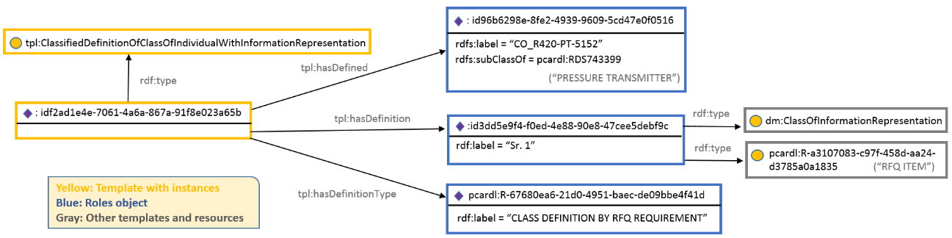
Figure 8 ClassifiedDefinitionOfClassOfIndividualWithInformationRepresentation template instantiation
The represented information described in the specification (see link above) says that:
“Members of [hasDefined] are defined as [hasDefinition] according [hasDefinitionType].”
For the instance of the template (idf2a…), one can say:
“Members of [CO_R420-PT-5152] (subclass of PRESSURE TRANSMITTER) are defined as [Sr. 1] according [CLASS DEFINITION BY RFQ REQUIREMENT]”,

which means that
“The Request For Quotation Sr. 1 and the requirements are related to the pressure transmitter CO_R420-PT-5152”.

Problems identified

- As pointed out in the specification, “at instantiation of this template it is mandatory to add meta:valEffectiveDate with the dateTime that the represented information became effective”. This instance does not contain this date required.

Reply to the RFQ information

The reply to the Request for Quotation information for one pressure transmitter file (pressure_transmitter_rfq_1_reply.ttl) comprises all the resources presented in the request file (pressure_transmitter_rfq_1.ttl) together with other five resources that represents the quotation. The templates and its instances in bold are presented in next sections.
Resource | rdf:type | Section
pressure_transmitter_rfq_1_reply: id09596342-9f7b-41b2-9609-ff5a88ded337 | dm:ClassOfArrangedIndividual, dm:ClassOfInformationRepresentation
pressure_transmitter_rfq_1_reply:id2d28890e-6acc-4e7f-a83f-a5656d145a76 | pcardl:R-bd9e51e1-7182-421d-887e-e5cb37e34653 ("QUOTATION")
pressure_transmitter_rfq_1_reply:id3161308c-abbc-49c9-aeba-be0cce92e7e1 | tpl:ProductClassFulfilsClassOfFunctionPlace | 3.1
pressure_transmitter_rfq_1_reply:id3e56ba39-663b-47e2-9ac4-00849a35c53b | tpl:ClassOfIndividualHasMonetaryValue | 3.2
pressure_transmitter_rfq_1_reply:id4ec28a4d-aab7-4f5b-936b-8820d731830e | tpl:ClassifiedDefinitionOfClassOfIndividual WithInformationRepresentation | 3.3

Template ProductClassFulfilsClassOfFunctionPlace

The template specification is shown in http://15926.org/templatespecs/CL-FUNC-08.xml?cachebuster=0.82030400%201441117215
The template roles are the following (see link above):
Role No | Role Name | Role Object Type
1 | hasFunctionPlaceClass | dm:ClassOfArrangedIndividual
2 | hasProductClass | dm:ClassOfArrangedIndividual
3 | hasClassOfFulfilled | dm:ClassOfArrangedIndividual

Figure 9 shows the ProductClassFulfilsClassOfFunctionPlace template instance of the pressure_transmitter_rfq_1_reply.ttl file.
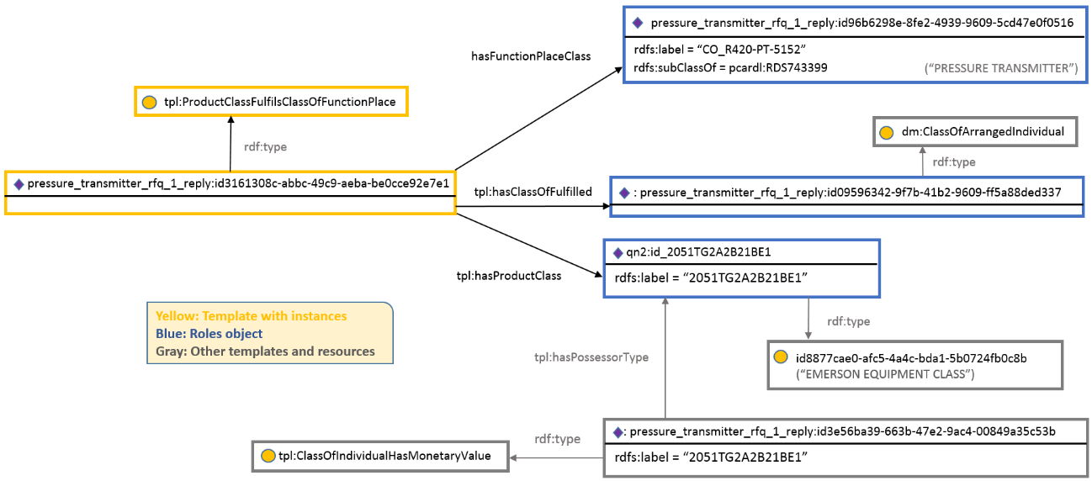
Figure 9 ProductClassFulfilsClassOfFunctionPlace template instantiation
The represented information described in the specification (see link above) says that:
“Any member of a class-of-temporal-part of Product Class [hasProductClass] fulfils the requirements of any member of a class-of-temporal-part of Process Design Item [hasFunctionPlaceClass]”
For the instance of the template (id316…), one can say:
“Any member of a class-of-temporal-part of Product Class [2051TG2A2B21BE1] (type EMERSON EQUIPMENT CLASS) fulfils the requirements of any member of a class-of-temporal-part of Process Design Item [CO_R420-PT-5152]”

which means that
“The EMERSON EQUIPMENT CLASS 2051TG2A2B21BE1 fulfil the requirements for the CO_R420-PT-5152 PRESSURE TRANSMITTER”.

3.1.1 Problems identified

- As pointed out in the specification, “at instantiation of this template it is mandatory to add meta:valEffectiveDate with the dateTime that the represented information became effective”. This instance does not contain this date required.

Template ClassOfIndividualHasMonetaryValue

The template specification is shown in http://15926.org/templatespecs/CL-INDPTY-07.xml?cachebuster=0.82274400%201441117215
The template roles are the following (see link above):
Role No | Role Name | Role Object Type
1 | hasPossessorType | dm:ClassOfIndividual
2 | hasCostType | dm:ClassOfIndirectProperty
3 | valPropertyValue | dm:ExpressReal
4 | hasCurrency | dm:Scale

Figure 10 shows the ClassOfIndividualHasMonetaryValue template instance of the pressure_transmitter_rfq_1_reply.ttl file.
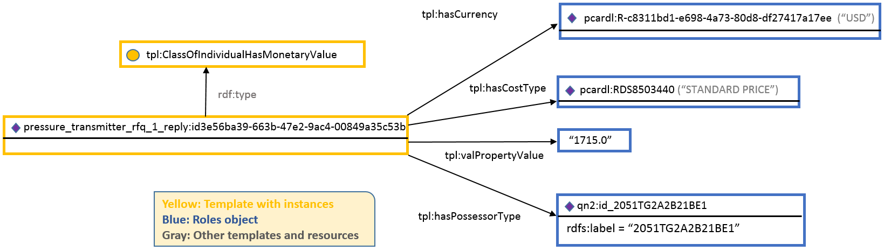
Figure 10 ClassOfIndividualHasMonetaryValue template instantiation
The represented information described in the specification (see link above) says that:
“Any member of [hasPossessorType] has a [hasIndirectPropertyType] with a value of [valPointValue] [hasScale].”
For the instance of the template (id3e5…), one can say:
“Any member of [2051TG2A2B21BE1] has a [STANDARD PRICE] with a value of [1715.0] [USD]”

which means that
“The Quotation for the 2051TG2A2B21BE1 product has as standard price 1715 USD”.

Problems identified

- As pointed out in the specification, “at instantiation of this template it is mandatory to add meta:valEffectiveDate with the dateTime that the represented information became effective”. This instance does not contain this date required.

Template ClassifiedDefinitionOfClassOfIndividualWithInformationRepresentation

The template specification is shown in http://www.15926.org/templatespecs/CL-DEFN-02a1.xml
The template roles are the following (see link above):
Role No | Role Name | Role Object Type
1 | hasDefined | dm:ClassOfIndividual
2 | hasDefinition | dm:ClassOfInformationRepresentation
3 | hasDefinitionType | dm:ClassOfClassOfDefinition

Problems identified

- As pointed out in the specification, “at instantiation of this template it is mandatory to add meta:valEffectiveDate with the dateTime that the represented information became effective”. This instance does not contain this date required.
- The template instance roles in the reply file are not consistent with the template specification (instead of the hasDefined, hasDefinition and hasDefinitionType, the instance id4ec… uses the roles tpl:hasDescribed, tpl:hasDescription and tpl:hasDescriptionType).

Proposal

This Section describes a proposal for solving the inconsistencies found in the pressure_transmitter_rfq_1.ttl file (only for that file) described in the previous Sections. The new instances are shown as follows (it is presented at the file pressure_transmitter_rfq_1_tec.ttl). The orange colored text represents suggestions to fill the gaps found or to correct the inconsistencies and the texts after the symbol "//" are comments.
:id00394ae2-f71f-4d9b-b23e-0921320a2292
rdf:type tpl:ClassOfAssemblyDefinition ;
tpl:hasClassOfPart :id0109f0bf-ac9d-411f-85cd-785ee3194d9e ;
tpl:hasClassOfWhole :id96b6298e-8fe2-4939-9609-5cd47e0f0516 ;
meta:valEffectiveDate "2015-09-08T11:00:00+00:00";
tpl:hasCardinalityOfRole :CardinalityX;
tpl:hasCardinalityOfPart : CardinalityX;
.
:id0109f0bf-ac9d-411f-85cd-785ee3194d9e
rdf:type dm:ClassOfInanimatePhysicalObject ;
rdfs:label "PE_R420-PT-5152" ;
rdfs:subClassOf pcardl:RDS462104 ;
.
:id05796c76-5f03-4e11-9a02-a1db079abec7
rdf:type dm:ClassOfInanimatePhysicalObject ;
rdfs:subClassOf pcardl:RDS11008205 ;
.
:id05c6754c-b2b7-4a7f-89c1-5e31940b5516
rdf:type dm:ClassOfInanimatePhysicalObject ;
rdfs:label "S_R420-PT-5152" ;
rdfs:subClassOf pcardl:RDS13026796 ;
.
:idX // auxiliary element to be created
rdf:type dm:ClassOfParticipation;

:id0c73c960-9164-46f3-959a-70a6fd5a31b2
rdf:type tpl:ClassOfParticipationDefinition ;
tpl:hasActivityType :id69516a23-2029-4f05-a714-3d269cc78de5 ;
tpl:hasParticipantRole pcardl:RDS13652847 ;
tpl:hasParticipantType :id83f1614d-649b-4876-ae1e-34721972e9bc ;
meta:valEffectiveDate "2015-09-08T11:00:00+00:00";
tpl:hasDefined :idX;
tpl:hasCardinalityOfActivity : CardinalityX; // (to be reviewed)
tpl:hasCardinalityOfParticipant : CardinalityX; // (to be reviewed)
.
:id0e7d3ad9-ab84-43f9-9f1a-9b980dfe7973
rdf:type tpl:SpecializationOfClassOfIndividual ;
tpl:hasSubClass :id73806964-ca9a-4b2a-a997-13d6a57d4c6d ;
tpl:hasSuperClass pcardl:RDS9062776044 ;
.
:id1395ad4b-81d5-4f46-a90b-7593f98edd32
rdf:type tpl:ClassifiedIdentificationOfIndividual ;
tpl:hasIdentificationType pcardl:R-0d8da6d3-bf11-4e17-bdeb-fcfcbeb32490 ;
tpl:hasIdentified :id91a437fa-20de-470b-83d0-2cdfe4a61914 ;
tpl:valIdentifier "R420-PT-5152" ;
meta:valEffectiveDate "2015-09-08T11:00:00+00:00";
.
:id1d2bf4dc-6b26-44a7-a5ba-96a4784ecd44
rdf:type tpl:ClassOfFeatureWholePartDefinition ;
tpl:hasClassOfPart :id73806964-ca9a-4b2a-a997-13d6a57d4c6d ;
tpl:hasClassOfWhole :id96b6298e-8fe2-4939-9609-5cd47e0f0516 ;
meta:valEffectiveDate "2015-09-08T11:00:00+00:00";
.
:id1f575f73-ea84-43ab-8980-b647f73965d4
rdf:type tpl:SpecializationByCompoundType ;
tpl:hasSubClass :id05796c76-5f03-4e11-9a02-a1db079abec7 ;
tpl:hasSuperClass pcardl:RDS480059 ;
.
:id20a39ca3-eb99-44be-aacf-8dae3b3f99cb
rdf:type pcardl:R-4d2153f8-2b65-4bee-9efb-a2fcac12f284 ;
rdf:type dm:ClassOfInformationRepresentation ;
rdfs:label "RFQ-001" ;
.
:id24bb682e-d3c8-4245-999c-d31cf54f664a
rdf:type tpl:SpecializationByCompoundType ;
tpl:hasSubClass :id0109f0bf-ac9d-411f-85cd-785ee3194d9e ;
tpl:hasSuperClass pcardl:RDS472229 ;
.
:id3dd5e9f4-f0ed-4e88-90e8-47cee5debf9c
rdf:type pcardl:R-a3107083-c97f-458d-aa24-d3785a0a1835 ;
rdf:type dm:ClassOfInformationRepresentation ;
rdfs:label "1" ;
.
:id3ff4a9d3-be07-4679-84aa-e25c1daac45c
rdf:type tpl:ClassOfAssemblyDefinition ;
tpl:hasClassOfPart :id05796c76-5f03-4e11-9a02-a1db079abec7 ;
tpl:hasClassOfWhole :id96b6298e-8fe2-4939-9609-5cd47e0f0516 ;
.
:id42d99e6e-a100-4574-865b-dcb1761ef742
rdf:type tpl:SpecializationOfClassOfIndividual ;
tpl:hasSubClass :id96b6298e-8fe2-4939-9609-5cd47e0f0516 ;
tpl:hasSuperClass pcardl:R-1ea100f5-e301-4528-bc51-9ab95b73d5f5 ;
.
:id5a5afdec-c690-4a37-a869-6b33d15dd92a
rdf:type tpl:ClassOfIndividualHasIndirectPropertyWithValue ;
tpl:hasIndirectPropertyType pcardl:RDS369629 ;
tpl:hasPossessorType :id05c6754c-b2b7-4a7f-89c1-5e31940b5516 ;
tpl:hasScale pcardl:RDS1348874 ;
tpl:valPropertyValue "19.2" ;
.
:id69516a23-2029-4f05-a714-3d269cc78de5
rdf:type dm:ClassOfActivity ;
rdfs:subClassOf pcardl:RDS9652247 ;
.
:id7176e82f-fe79-43eb-b7c3-6f8132751085
rdf:type dm:ClassOfArrangedIndividual ;
rdfs:subClassOf pcardl:RDS9551659 ;
.
:id73806964-ca9a-4b2a-a997-13d6a57d4c6d
rdf:type dm:ClassOfArrangedIndividual ;
rdfs:subClassOf pcardl:RDS1442382761 ;
.
:id75fe4685-a1f7-4e88-b4c5-9b0a9fa707fa
rdf:type tpl:ClassOfParticipationDefinition ;
tpl:hasActivityType :id69516a23-2029-4f05-a714-3d269cc78de5 ;
tpl:hasParticipantRole pcardl:R-d2f7bbdf-0314-417b-b50b-b4fa4b6cd897 ;
tpl:hasParticipantType :id96b6298e-8fe2-4939-9609-5cd47e0f0516 ;
.
:id7cbfe727-ba44-49fe-83d2-50c5edb17e5d
rdf:type tpl:ClassOfIndividualHasIndirectPropertyWithBoundingValues ;
tpl:hasIndirectPropertyType pcardl:R-172326ab-22d4-4ba0-be6e-f2f4890e8185 ;
tpl:hasPossessorType :id96b6298e-8fe2-4939-9609-5cd47e0f0516 ;
tpl:hasScale pcardl:RDS1348874 ;
tpl:valLowerBound "0" ;
tpl:valUpperBound "30.0" ;
.
:id83f1614d-649b-4876-ae1e-34721972e9bc
rdf:type dm:ClassOfArrangedIndividual ;
rdfs:subClassOf pcardl:RDS337196911 ;
.
:id84217d48-1196-439b-8dfe-cfcd7376b08c
rdf:type tpl:SpecializationOfClassOfIndividual ;
tpl:hasSubClass :id83f1614d-649b-4876-ae1e-34721972e9bc ;
tpl:hasSuperClass pcardl:R-9589eb0d-8276-40b8-9ada-8d79cf1c7101 ;
.
:id91a437fa-20de-470b-83d0-2cdfe4a61914
rdf:type dm:FunctionalPhysicalObject ;
rdfs:label "R420-PT-5152" ;
.
:id96b6298e-8fe2-4939-9609-5cd47e0f0516
rdf:type pcardl:R-c898dddf-932e-4216-bf99-0f40df3847f4 ;
rdf:type dm:ClassOfInanimatePhysicalObject ;
rdfs:label "CO_R420-PT-5152" ;
rdfs:subClassOf pcardl:RDS354194 RDS743399 ; // the right is PRESSURE TRANSMITTER, not PRESSURE
.
:idc10d6602-0aa9-4a71-8579-9e8c18dac8de
rdf:type tpl:ClassOfContainmentDefinition ;
tpl:hasClassOfContained :id05c6754c-b2b7-4a7f-89c1-5e31940b5516 ;
tpl:hasClassOfContainer :id96b6298e-8fe2-4939-9609-5cd47e0f0516 ;
tpl:hasCardinalityOfContainer :RDSNEW004; // (to be reviewed)
tpl:hasCardinalityOfContained :RDSNEW004; // (to be reviewed)
.
:idc1b54729-7deb-4764-a16a-0a9d29b1582e
rdf:type tpl:CompositionOfClassOfInformationRepresentation ;
tpl:hasPart :id3dd5e9f4-f0ed-4e88-90e8-47cee5debf9c ;
tpl:hasWhole :id20a39ca3-eb99-44be-aacf-8dae3b3f99cb ;
.
:idc5c4e0d5-f495-4fc8-96f3-5e8fb8944fb6
rdf:type tpl:SpecializationOfClassOfIndividual ;
tpl:hasSubClass :id0109f0bf-ac9d-411f-85cd-785ee3194d9e ;
tpl:hasSuperClass pcardl:RDS429389 ;
.
:idef595e28-52b2-42fd-b714-1368087d85e7
rdf:type tpl:ClassOfFeatureWholePartDefinition ;
tpl:hasClassOfPart :id7176e82f-fe79-43eb-b7c3-6f8132751085 ;
tpl:hasClassOfWhole :id96b6298e-8fe2-4939-9609-5cd47e0f0516 ;
tpl:hasCardinalityOfWhole : CardinalityX;
tpl:hasCardinalityOfPart : CardinalityX;
.
:idf2ad1e4e-7061-4a6a-867a-91f8e023a65b
rdf:type tpl:ClassifiedDefinitionOfClassOfIndividualByCOIR ;
tpl:hasDefined :id96b6298e-8fe2-4939-9609-5cd47e0f0516 ;
tpl:hasDefinition :id3dd5e9f4-f0ed-4e88-90e8-47cee5debf9c ;
tpl:hasDefinitionType pcardl:R-67680ea6-21d0-4951-baec-de09bbe4f41d ;
.
:idf84912f2-0994-4ac5-b0b1-dd64376dd345
rdf:type tpl:ClassOfIndividualHasIndirectPropertyWithValue ;
tpl:hasIndirectPropertyType pcardl:RDS369674 ;
tpl:hasPossessorType :id05c6754c-b2b7-4a7f-89c1-5e31940b5516 ;
tpl:hasScale pcardl:RDS1322684 ;
tpl:valPropertyValue "95.0" ;
.
:idf9f811d7-6344-49f1-82aa-1da40a7c2db0
rdf:type tpl:SpecializationOfClassOfIndividual ;
tpl:hasSubClass :id7176e82f-fe79-43eb-b7c3-6f8132751085 ;
tpl:hasSuperClass pcardl:RDS1459162771 ;
.
:idfdc37bd5-690c-4596-b603-677ba6f7d88a
rdf:type tpl:ClassificationOfIndividual ;
tpl:hasClassified :id91a437fa-20de-470b-83d0-2cdfe4a61914 ;
tpl:hasClassifier :id96b6298e-8fe2-4939-9609-5cd47e0f0516 ;
.
<http://iso15926.fiatech.org/edrc_usecase_2/pressure_transmitter_rfq_1>
rdf:type owl:Ontology ;
owl:imports tpl: ;
owl:versionInfo "Created with TopBraid Composer"^^xsd:string ;
.
The files presented at the directory "edrc_usecase_2 - changed by TecGraf," allows to test the EDRC UC2 with answering real SPARQL queries. The reader can see it at the document UC2_SPARQL_Examples.pdf

Data Specification

This section brings a First Order Logic representation of the Object Declarations and the Templates Patterns used to construct the EDRC User Case 2. The main goal of this section is to show the connection between the classes, templates and patterns to model the information or data.

5.1 Object Declarations

At the FOL formula below, the predicates are used to define properties and some predicates are not in Part 7 of ISO15926. These predicates are:

- Identification(x) - it means that x is an identifier;
- RequestforQuotation(x) - it means that x is a Request for Quotation;
- TaggedItemObject(x) - it means that x is a Tagged Item;
- EquipmentType(x) - it means that x is an Equipment Type;
- RequiredItemClass(x) - it means that x is a Required Item;
- PressureElement(x) - it means that x is a Pressure Element;
- Stream(x) - it means that x is a Stream;
- Quotation(x) - it means that x is a Quotation;
- RFQItem(x) - it means that x is a Request for Quotation Item;
- ClassificationProperty(x,y) - it means that x is classified as y;
- IdentificationProperty(x,y) - it means that x has the label y;
- SpecializationProperty (x, y ) - it means that x is subclass of y.

Note: In the specification of the Template Pattern, it is possible to use directly FOL predicates and proto-templates defined in ISO15926-7. However, Object declarations are designed to be implemented without templates.

Request for Quotation
RequestforQuotationObjectDeclaration(y,z,k) ->
ClassOfInformationRepresentation(y)^
RequestforQuotation(z)^
Identification(k) ^
ExpressString(k)^
ClassificationProperty(z,y) ^
IdentificationProperty(y,k) .

Instance example: RequestforQuotationObjectDeclaration (InformationRepresentationY, RequestForQuotationX, "RFQ_0001").

The RequestForQuotationX is classified as InformationRepresentationY and has the identifier RFQ_0001.

Tagged Item
TaggedItemObjectDeclaration (y,z,k) ->
FunctionalPhysicalObject(y)^
TaggedItemObject(z)^
Identification(k) ^
ExpressString(k)^
ClassificationProperty(z,y) ^
IdentificationProperty(y,k) .

Instance example: TaggedItemObjectDeclaration (FunctionalPhysicalObjectY, TaggedItemObjectZ, "R420-PT-6501").

The TaggedItemObjectZ, is classified as FunctionalPhysicalObjectY and has the identifier R420-PT-6501.

Required Class
RequiredClassObjectDeclaration (x, y,z,k) ->
ClassOfInanimatePhysicalObject(x) ^
Identification(y)^
ExpressString(y)^
EquipmentType(z)^
RequiredItemClass(k) ^
ClassificationProperty(k,x) ^
IdentificationProperty (x,y) ^
SpecializationProperty (x,z) .

Instance example: RequiredClassObjectDeclaration (InanimatePhysicalObjectX, "CO_R420-PT-6501", EquipmentTypeX, RequiredItemClassZ).

The InanimatePhysicalObjectX is classified as RequiredItemClassZ, is subclass of EquipmentTypeX and has the identifier CO_R420-PT-6501.

Note: the EquipmentTypeX is a Data set element (RDL entity), it can be PRESSURE TRANSMITTER http://posccaesar.org/rdl/RDS743399

Pressure Element Class

PressureElementClassObjectDeclaration(x, y,z) ->
ClassOfInanimatePhysicalObject(x)^
Identification(y) ^
ExpressString(y)^
PressureElement(z)^
IdentificationProperty (x,y) ^
SpecializationProperty (x,z) .

Instance example: PressureElementClassObjectDeclaration (InanimatePhysicalObjectX," PE_R420-PT-6501", PressureElementZ).

The InanimatePhysicalObjectX is subclass of PressureElementZ and has the identifier PE_R420-PT-6501.

Stream Class

StreamClassObjectDeclaration(x,y,z) ->
ClassOfInanimatePhysicalObject(x)^
Identification (y)^
ExpressString(y)^
Stream(z)^
IdentificationProperty(x,y) ^
SpecializationProperty (x,z) .

Instance example: StreamClassObjectDeclaration (InanimatePhysicalObjectX,"S_R420-PT-6501", StreamZ).

The InanimatePhysicalObjectX is subclass of StreamZ and has the identifier S_R420-PT-6501

Reply to the Request for Quotation
ReplytotheRequestforQuotationObjectDeclaration(y,z,k) ->
ClassOfInformationRepresentation(y)^
Quotation(z)^
Identification(k)^
ExpressString(k)^
ClassificationProperty(z,y) ^
IdentificationProperty (y,k) .

Instance example: Reply to the Request forQuotationDeclaration (InformationY,QuotationZ, "RFQ_0001_Reply").
The InformationY is classified as QuotationZ and has the identifier RFQ_0001_Reply.

RFQ Item

RFQItemObjectDeclaration(y,k,z) ->
ClassOfInanimatePhysicalObject(y)^
Identification(k)^
ExpressString(k)^
RFQItem(z)^
IdentificationProperty (y,k) ^
ClassificationProperty (y,z) .

Instance example RFQItemObjectDeclaration (InanimatePhysicalObjectY,"Sr.1", RFQItemZ).
The InanimatePhyscalObjectY has a RFQItemZ and has the identifier Sr.1.

5.2 Template Pattern
The formulas bellow represent requirements for the request for quote about the pressure transmitter (request and reply) and its specification.

Pressure_Transmitter_RFQ (X1, X2, X3, X4, X5, X6,X7, X8, C1, X9,X10, C2, X11, X12, C3,
X13, X14, X15, X16, X17, X18, X19, X20, X21, X22, X23, X24, X25, X26, X27, X28, X29, X30)

->
TagNumber(X1, X2, X3, X4) ^
OperatingPressure(X4, X5, X6, X7, X8, C1, X9) ^
OperatingTemperature(X4, X5, X6, X7, X10, C2, X11) ^
CalibrationRange (X4, X12, C3, X9) ^
ProductCertification (X4, X13) ^
Output (X14, X15, X4, X16, X17, X18) ^
ElementType(X4, X19, X20) ^
ElementMaterial (X4, X19, X21) ^
HousingMaterial (X4, X22, X23) ^
ElectricalConnectionType(X4, X24, X25) ^
ProcessConnectionType(X26, X4, X27) ^
DefinitionOfClassByRQFDocument(X28, X29, X4, X30).

Pressure_Transmitter_RFQ_Reply (X1, X2, X3, X4, X5, X6, X7, x8, C1, X9, X10, C2, X11, X12, C3, X13, X14, X15, X16, X17, X18, X20, X21, X22, X23, X24, X25, PC, PCN, X28, X29, X30, R1, R2, R3, R4, C4, R5)

->
TagNumber(X1, X2, X3, X4) ^
OperatingPressure(X4, X5, X6, X7, x8, C1, X9) ^
OperatingTemperature(X4, X5, X6, X7, X10, C2, X11) ^
CalibrationRange (X4, X12, C3, X9) ^
ProductCertification (X4, X13) ^
Output (X14, X15, X4, X16, X17, X18) ^
ElementType(X4, X19, X20) ^
ElementMaterial (X4, X19, X21) ^
HousingMaterial (X4, X22, X23) ^
ElectricalConnectionType(X4, X24, X25) ^
ProcessConnectionType(X26, X4, X27) ^
DefinitionOfClassByRQFDocument(X28, X29, X4, X30) ^
ModelNumber (X4, X28, R1, R2, R3, R4, C4, R5 ) .

TagNumber(X1, X2, X3, X4) ->
ClassifiedIdentificationOfIndividual(X1, X2, X3) ^
ClassificationOfIndiviual (X1, X4).

OperatingPressure(X4, X5, X6, X7, x8, C1, X9) ->
ClassOfContainmentDefinition(X4, X5, X6, X7) ^
ClassOfIndividualHasIndirectPropertyWithValue(X5, x8, C1, X9).

OperatingTemperature(X4, X5, X6, X7, X10, C2, X11) - >
ClassOfContainmentDefinition(X4, X5, X6, X7) ^
ClassOfIndividualHasIndirectPropertyWithValue(X5, X10, C2, X11).
CalibrationRange (X4, X12, C3, X9) - >
ClassOfIndividualHasIndirectPropertyWithMaximumValue (X4, X12, C3, X9).

ProductCertification (X4, X13) - >
SpecializationOfClassOfIndividual (X4, X13).

Output (X14, X15, X4, X16, X17, X18) ->
SpecializatioNOPfClassOfIndividual(X14, X15) ^
ClassOfParticipationDefinition (X4, X16, X17) ^
ClassOfParticipationDefinition (X14, X16, X18).

ElementType(X4, X19, X20) ->
ClassOfAssemblyDefinition(X4, X19) ^
SpecializationOfClassOfIndividual(X19, X20).

ElementMaterial (X4, X19, X21) ->
ClassOfAssemblyDefinition(X4, X19) ^
SpecializationByCoumpoundType(X19, X21).

HousingMaterial (X4, X22, X23) ->
ClassOfAssemblyDefinition(X4, X22) ^
SpecializationByCoumpoundType(X22, X23).

ElectricalConnectionType(X4, X24, X25) ->
ClassOfFeatureWholePartDefinition (X24, X4) ^
SpecializationOfClassOfIndividual(X25, X24).

ProcessConnectionType(X26, X4, X27) ->
ClassOfFeatureWholePartDefinition (X26, X4) ^
SpecializationOfClassOfIndividual(X27, X26).

DefinitionOfClassByRQFDocument(X28, X29, X4, X30) ->
CompositionOfClassOfInformationRepresentation(X28, X29) ^
ClassifiedIdentificationOfIndividualWithInformationRepresentation (X4, X28, X30).

ModelNumber (X4, X28, R1, R2, R3, R1, R4, C4, R5) ->
ClassifiedIdentificationOfIndividualWithInformationRepresentation(X4, X28, R1) ^
ProductClassFulfilsClassOfFunctionPlace(X4, R3, R2) ^
IndividualHasMonetaryValue (R3, R4, C4, R5).

The formulas bellow represents the instantiation of the formula shown above (request and reply). The instance is essential to understand how the objects are build based on the patterns and using the templates.

Note2: The labels described as follows are taken from (i) the own object label or (ii) the rdfs:subClassOf property or (iii) the tpl:hasSuperClass property.

Note3: The instantiation process must be applied to all patterns and template. Here is showed the instantiation for just the more external patterns.

Notation of some constants:
id91a... = CompanyNamespace+Project ID + TagNumber or CompanyNamespace + UUID
id0959... = ClassOfArrangedIndividual
CO_R420-PT-5152 = Company’s PRESSURE TRANSMITTER
R420-PT-5152 = PRESSURE TRANSMITTER tag
S_R420-PT-5152 = PRESSURE TRANSMITTER STREAM
PE_R420-PT-5152 = PRESSURE ELEMENT
cardinality1 = cardinality to be defined by PCA
cardinality2 = cardinality to be defined by PCA

Formulas:

Pressure_Transmitter_RFQ ("id91a...", "R420-PT-5152", "TAG ASSIGNMENT CLASS", "CO_R420-PT-5152", "S_R420-PT-5152", "cardinality1","cardinality2", "NORMAL OPERATING PRESSURE", 19.2, "BAR GAUGE","NORMAL OPERATING TEMPERATURE", 95.0, "DEGREE CELSIUS", "CALIBRATION RANGE", 30, "ATEX FLAME PROOF", "SIGNAL","4_20mA, HART","TRANSMITTING", "PERFORMER", "OUTPUT", "PE_R420-PT-5152","ISOLATING DIAPHGRAM","ASTM GRADE 316L", "HOUSING", "ALLUMINIUN", "ELECTRICAL CONNECTION", "THREADED HOLE M20 X 1.5F", "PROCESS CONNECTION", "PROCESS CONNECTION 1/2 -14 NPT","Sr.1","RFQ-001", "CLASS DEFINITION BY X29 REQUIREMENT")
->

TagNumber("id91a...","R420-PT-5152","TAG ASSIGNMENT CLASS", "CO_R420-PT-5152") ^

OperatingPressure("CO_R420-PT-5152","S_R420-PT-5152","cardinality1","cardinality2", "NORMAL OPERATING PRESSURE", 19.2, "BAR GAUGE") ^

OperatingTemperature("CO_R420-PT-5152","S_R420-PT-5152","cardinality1","cardinality2", "NORMAL OPERATING TEMPERATURE", 95.0, "DEGREE CELSIUS") ^

CalibrationRange ("CO_R420-PT-5152","CALIBRATION RANGE", 30,"BAR GAUGE") ^

ProductCertification ("CO_R420-PT-5152", "ATEX FLAME PROOF") ^

Output ("SIGNAL","4_20mA, HART","CO_R420-PT-5152","TRANSMITTING", "PERFORMER", "OUTPUT") ^

ElementType ("CO_R420-PT-5152", "PE_R420-PT-5152", "ISOLATING DIAPHGRAM") ^

ElementMaterial ("CO_R420-PT-5152","PE_R420-PT-5152", "ASTM GRADE 316L") ^

HousingMaterial ("CO_R420-PT-5152","HOUSING","ALLUMINIUN") ^

ElectricalConnectionType ("CO_R420-PT-5152","ELECTRICAL CONNECTION", "THREADED HOLE M20 X 1.5F") ^

ProcessConnectionType ("PROCESS CONNECTION" ,"CO_R420-PT-5152", "PROCESS CONNECTION 1/2 -14 NPT") ^

DefinitionOfClassByRQFDocument ("Sr.1","RFQ-001","CO_R420-PT-5152","CLASS DEFINITION BY RQF REQUIREMENT") .

Pressure_Transmitter_RFQ_Reply ("id91a...","R420-PT-5152", "TAG ASSIGNMENT CLASS", "CO_R420-PT-5152", "S_R420-PT-5152", "cardinality1","cardinality2", "NORMAL OPERATING PRESSURE", 19.2, "BAR GAUGE","NORMAL OPERATING TEMPERATURE", 95.0, "DEGREE CELSIUS", "CALIBRATION RANGE", 30, "ATEX FLAME PROOF", "SIGNAL","4_20mA,HART","TRANSMITTING", "PERFORMER", "OUTPUT", "PE_R420-PT-5152","ISOLATING DIAPHGRAM","ASTM GRADE 316L", "HOUSING","ALLUMINIUN", "ELECTRICAL CONNECTION", "THREADED HOLE M20 X 1.5F", "PROCESS CONNECTION", "PROCESS CONNECTION 1/2 -14 NPT","Sr.1","RFQ-001", "CLASS DEFINITION BY RQF REQUIREMENT", "CLASS DESCRIPTION BY QUOTATION", "id0959...", "2051TG2A2B21BE1 - EMERSON EQUIPAMENT CLASS" , "STANDARD PRICE", 1715, "USD" )

->

TagNumber("id91a...","R420-PT-5152","TAG ASSIGNMENT CLASS", "CO_R420-PT-5152") ^

OperatingPressure("CO_R420-PT-5152","S_R420-PT-5152","cardinality1","cardinality2", "NORMAL OPERATING PRESSURE", 19.2, "BAR GAUGE")^

OperatingTemperature("CO_R420-PT-5152","S_R420-PT-5152","cardinality1","cardinality2", "NORMAL OPERATING TEMPERATURE", 95.0, "DEGREE CELSIUS") ^

CalibrationRange ("CO_R420-PT-5152","CALIBRATION RANGE", 30,"BAR GAUGE") ^

ProductCertification ("CO_R420-PT-5152", "ATEX FLAME PROOF") ^

Output ("SIGNAL","4_20mA, HART","CO_R420-PT-5152", "TRANSMITTING", "PERFORMER", "OUTPUT") ^

ElementType("CO_R420-PT-5152", "PE_R420-PT-5152", "ISOLATING DIAPHGRAM") ^

ElementMaterial ("CO_R420-PT-5152","PE_R420-PT-5152", "ASTM GRADE 316L") ^

HousingMaterial ("CO_R420-PT-5152","HOUSING","ALLUMINIUN") ^

ElectricalConnectionType("CO_R420-PT-5152","ELECTRICAL CONNECTION", "THREADED HOLE M20 X 1.5F") ^

ProcessConnectionType("PROCESS CONNECTION" ,"CO_R420-PT-5152", "PROCESS CONNECTION 1/2 -14 NPT") ^

DefinitionOfClassByRQFDocument("Sr.1","RFQ-001","CO_R420-PT-5152","CLASS DEFINITION BY RQF REQUIREMENT") ^

ModelNumber ("CO_R420-PT-5152", "Sr.1","CLASS DESCRIPTION BY QUOTATION", id0959..., "2051TG2A2B21BE1 - EMERSON EQUIPAMENT CLASS" , "STANDARD PRICE", 1715, "USD" ) .

This template is present on the EDRC Use Case 2 Technical Documentation using the previous name, "ClassifiedDefinitionOfClassOfIndividualByCOIR”.
Cardinality to be defined by PCA
In the mapping of the information to be accessed or data to be exchanged, to ISO 15926 reference data Classes and Templates, it was noticed certain sets of repeating patterns. The repetitive nature of the patterns allow the work to accelerate. When new requirements have been identified with similar semantics already mapped to specific patterns, these same patterns have simply been applied to the new requirements[5]
see specification downloading the file at http://techinvestlab.ru/EDRCDemo

